PROJECT DOCUMENTATION

CLASSIC BAKERY

WEBPAGE

1. Popup menu with close button on right corner shows up when page is loaded
2. Menu shows the notifications and workers needed with CONTACT US button
3. Page is designed with Introduction and 3 Events with LIVE BACKGROUND IMAGE
4. HEADER with Company logo and some events with top right corner with sign up and add to cart
5. Scrolling down shows History of the Company and with some descriptions
6. Below that achievements made by the company
7. Place your order Button with some contents
8. The below/footer gives the content of follow us , contact us, places, branches where company runs
9. Graphical user interface, text, application

   Description automatically generated

WEBPAGE2

1. The page is with full of foods offered by the company to users/clients
2. Ex: Website

   Description automatically generated with medium confidence
3. When selecting a category/Event it should dropdown the menu offered under that category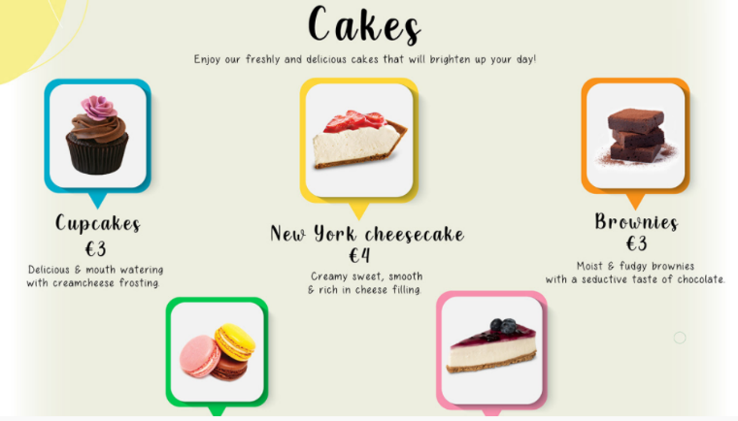
4. Selecting a food with add to cart system with number of quantities
5. And same footer like in Web page 1
6. When selecting a product scrolling down it should show suggested products also with the product ingredients

Admin user

1. Create an admin login with a password-forgotten system, complete registration, and authorization. The admin user should be able to create modify and delete
2. Admin users ought to have access to information about the product currently being provided to the client.
3. The admin user should have access to the user's purchase list.
4. After the payment success message/invoice should be sent to the client usersGraphical user interface, website

   Description automatically generated

CLIENT USER

1. Create a user login with complete registration authorisation email verification and forgot password system
2. Only authenticated users are permitted to place food orders.
3. If food is not available it should show out of stock
4. The admin and client user should be notified after the order is placed.

Header of the page :

Ex: